**Publish Tableau**

Server🡪tableau online –connect🡪give credentials🡪after login username will displays🡪

Server🡪publish workbook🡪.

Publish workbook to online🡪 project🡪select which you want (Tutorials point)🡪give description🡪

Tags:🡪pavan,sales,country. 🡪sheets🡪select required 🡪permissions (same as project tutorials)🡪ok.

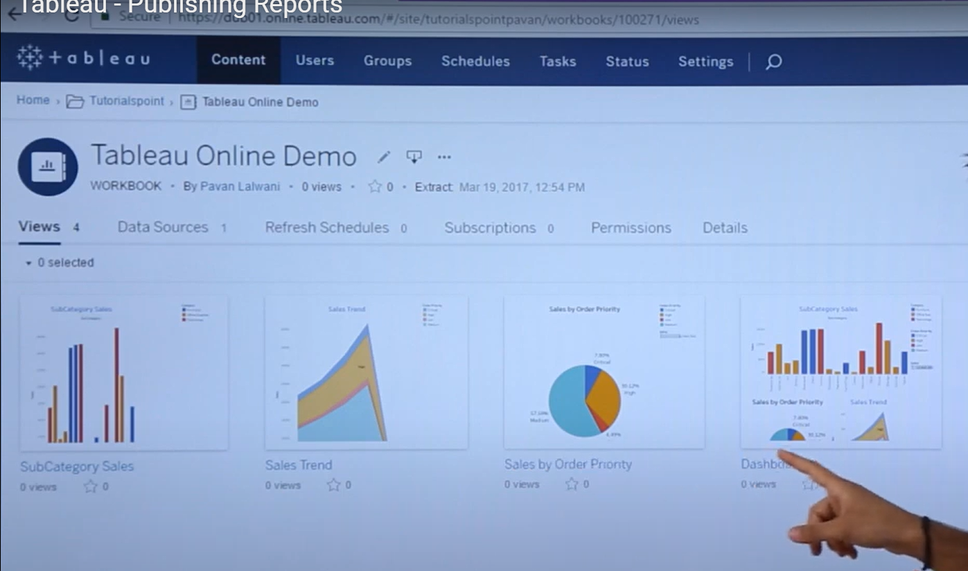

You want to see old publish worksheets: --

Server🡪open workbook🡪select required sheet🡪ok.